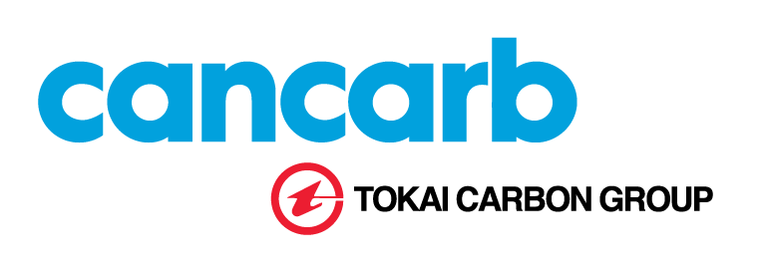

FOR IMMEDIATE RELEASE June 2, 2026

Cancarb Limited Celebrates Completion and Commissioning of New Solar Power Facility

Medicine Hat, Alberta – June 2, 2026 – Cancarb Limited proudly celebrated the official completion and commissioning of its new solar power facility today, marking a significant milestone in the company's ongoing commitment to sustainability, operational excellence, and long-term environmental stewardship.

The new solar installation represents an investment of more than $7 million and consists of over 7,000 solar panels with a generation capacity of approximately 3.5 megawatts (MW). The electricity produced by the facility will supply a substantial portion of the utility load for Cancarb's carbon black manufacturing operations in Medicine Hat.

Employees, project partners, local government representatives, along with Mr. H. Nagasaka, CEO of Tokai Carbon Co., Ltd. and Mr. N. Kawabe, General Manager of Tokai’s Carbon Black Division, gathered for the ceremony to recognize the completion of a project that demonstrates Cancarb's commitment to reducing its environmental footprint while strengthening the long-term sustainability of its operations.

"This project represents much more than just a solar power installation," said Peter Donnelly, President of Cancarb Limited. "It is a visible symbol of our commitment to sustainable manufacturing and our determination to secure a strong future for Cancarb, our employees, our customers, and our community. By investing in renewable energy today, we are taking meaningful steps toward reducing emissions while continuing to provide the high-quality products our customers depend on."

The solar facility is the largest renewable energy investment within the Tokai Carbon Group and the only utility-scale solar generation project integrated directly upstream of a thermal carbon black manufacturing operation anywhere in the world. It is also among the largest solar generation facilities within the City of Medicine Hat.

The project builds upon Cancarb's long-standing history of sustainability initiatives. More than twenty-five years ago, the company commissioned its waste heat recovery facility, capturing heat energy that would otherwise be lost and converting it into valuable electricity. The new solar facility complements those efforts and further advances the company's environmental objectives.

"While this project is modest in size compared to global energy infrastructure developments, its significance is substantial," said Donnelly. "It demonstrates to our customers, shareholders, and stakeholders that sustainability is an integral part of our business strategy and our future growth."

As a leading producer of thermal carbon black products marketed under the THERMAX® brand, Cancarb continues to invest in technologies and initiatives that enhance environmental performance, improve operational efficiency, and support the evolving sustainability expectations of customers worldwide.

About Cancarb Limited

Cancarb Limited, a member of the Tokai Carbon Group, is a global leader in the production of thermal carbon black products sold under the THERMAX® brand. From its manufacturing facility in Medicine Hat, Alberta, Cancarb supplies specialty carbon black products to customers around the world serving a diverse range of industrial and commercial applications. The company is committed to delivering exceptional product quality, customer service, operational excellence, and sustainable manufacturing practices.

Media Contact

Brad Thompson
Director, Global Sales & Marketing
Cancarb Limited
403-529-4351
brad_thompson@cancarb.com

